

|  |  |  |  |
| --- | --- | --- | --- |
| **NAME** |  | | |
| **SUBJECT:** BASIC TECHNOLOGY | | **CLASs:** J.S.S.1 | **DURATION:** 1 ½ HOURS |

INSTRUCTION: This paper consists of two sections. Answer ALL questions on section A and FOUR questions on section B (Question one is compulsory)

SECTION A: Objective (20 marks)

1. The small box used for keeping tools is known as ………………………
2. tools rack
3. tools box
4. tools shelf
5. tools cabinet
6. The types of building based on design include the following EXCEPT.
7. round house
8. flats house
9. stone house
10. skyscraper
11. The following are examples of boring tools EXCEPT ……………..
12. brace
13. bradawl
14. twist drill
15. keyhole
16. A wooden saw should be care for in the following ways EXCEPT…………………..
17. keep in cool dry place
18. sharpen when dull
19. hang in free space or without obstruction
20. not putting oil on the blade.
21. Which of the materials is NOT used in technology as material used for technical products?
22. Wood
23. Ceramics
24. Metal
25. internet
26. The following are measuring tools EXCEPT ………
27. micro screw gauge
28. depth gauge
29. surface plate
30. tape rule
31. The following are marking out tools EXCEPT …………….
32. punches
33. scriber
34. odd leg caliper
35. divider
36. The following are holding tools EXCEPT …………………
37. bench vice
38. G- clamp
39. plier
40. venier caliper
41. Which of the following is the metal worker pencil?
42. Divider
43. Punches
44. Scriber
45. Hammer
46. Which of the following is not a driving tool?
47. Hammer
48. Screwdriver
49. Brace
50. punch
51. One of the following is used for removing imperfection from a finished surface.
52. chisel
53. saw
54. scrapper
55. file
56. The type of circuit shown below is
57. 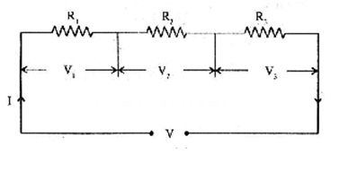series
58. parallel
59. closed
60. open
61. An atom comprises of proton and neutron in the nucleus and ………. In orbits.
62. elements
63. electrons
64. positive charges
65. particle
66. Electricity is energy from …………..
67. solar
68. charge particles
69. nuclear
70. wind.
71. The tool used for driving bolt and nut is
72. wrenches
73. pliers
74. screwdriver
75. stripper
76. 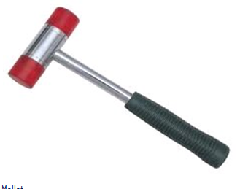The figure below is …………….
77. mallet
78. ball pein hammer
79. special hammer
80. sledge hammer
81. 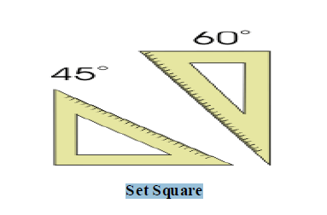The drawing instrument shown below is….
82. set square
83. try square
84. tee square
85. french curve.
86. Which of the following is not a grade of file?
87. Rough grade
88. Bastard grade
89. Second grade
90. Fine grade.
91. Which of the following hammer is used for riveting in metalwork?
92. Ball pein hammer
93. Cross pein hammer
94. Straight pein hammer
95. Special hammer
96. A room, especially one which is not particularly large, used for manufacturing or other light industrial work is called.
    1. a workshop
    2. a shop
    3. a laboratory
    4. a school.
97. An unexpected event with negative consequences occurring without the intention of the one suffering the consequences is called.
    1. injury
    2. accident
    3. victim
    4. safety.
98. Which of the following is not a safety device?
    1. Protective clothing
    2. Goggle
    3. Safety shoes
    4. Slippers
99. The act of removing and replacing faulty parts is known as ………
100. maintenance
101. overhauling
102. repair
103. servicing
104. The process of prolong the time a system function is known as ……….
105. maintenance
106. overhauling
107. repair
108. routine maintenance
109. The best form of maintenance is ………….
110. predictive maintenance
111. preventive maintenance
112. corrective maintenance
113. repair
114. The book of instructions and information about a machine is known as ……..
115. collections
116. catalogue
117. manual
118. book
119. The formula for calculating power in a circuit is
120. IR
121. I2R
122. ER
123. V/R
124. The instrument used to measure potential differences is.
125. voltmeter
126. ammeter
127. potentio meter
128. watt meter
129. The formula for calculating total resistance in a series circuit is.
130. RT = R1 + R2 + R3
131. R = + +
132. = + +
133. Which of the following is not a basic quantity in electricity
134. volt
135. resistance
136. current
137. oxidation
138. 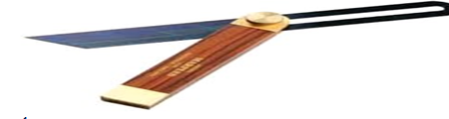The figure below is a …… in woodwork hand tools.
139. bevel gauage
140. deluxe gauge
141. sliding gauge
142. mortise gauge.
143. 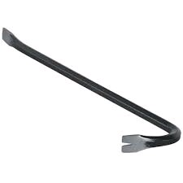The figure shown below is ……
144. crowbar
145. lever bar
146. push rod
147. mortar
148. One of the following is an instrument used to measure many variables.
149. voltmeter
150. ammeter
151. multimeter
152. potentio meter
153. The following tools are used for maintenance EXCEPT …………
154. manual
155. tester
156. hammer
157. catalogue
158. The gap between capacitors plate is called
159. electric
160. Dielectric
161. capacitance
162. pole
163. The symbol shown below represent …..
164. cell
165. switch
166. capacitor
167. transistor
168. Capacitor CANNOT be used in one of the following ….
169. air condition
170. electric motor
171. boiling ring
172. television
173. The symbol shown below is ………….
174. resistor
175. switch
176. electric bulb
177. earth
178. The electrical device that gives constant output for variable input voltage range is …..
179. transformer
180. stabilizer
181. electric motor
182. Inductor
183. 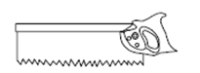The type of wooden saw shown below is …
184. rip saw
185. cross cut saw
186. tenon saw
187. band saw
188. The maintenance of faulty/ nonfunctioning radio is …….
189. predictive
190. preventive
191. corrective
192. 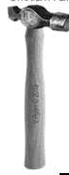routine
193. The metalwork handtools shown below is.
194. ball pein hammer
195. block hammer
196. sledge hammer
197. straight pein hammer
198. The metalwork handtools shown below is …

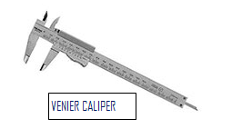

1. odd leg caliper
2. veneir caliper
3. inside caliper
4. outside caliper
5. The metal work tools shown bellow is …..
6. wrench
7. punch
8. screwdriver
9. gimlet
10. Which of the following is not electrical material?
11. Conductor
12. Insulator
13. Semiconductor
14. Water
15. 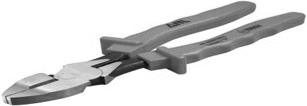The electrical tool shown below is …..
16. general pliers
17. clip pliers
18. long nose pliers
19. gripping pliers
20. The electrical symbol below represent …..
21. resistor
22. conductor
23. fuse
24. switch
25. 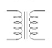The electrical symbol below is ……
26. switch
27. inductor
28. transformer
29. electric motor
30. The current in the circuit below is ………

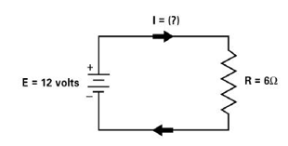

1. 3 amperes
2. 2 amperes
3. 4 amperes
4. 2.5 amperes
5. The figure below is an example of a/an ……….

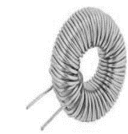

1. transformer
2. capacitor
3. resistor
4. inductor

**SECTION B {40 marks}**

Instruction: i. Answer FOUR questions from this section, question ONE is compulsory and any other THREE.

ii. Use all necessary drawing instruments and materials where applicable.

iii. Credit will be awarded for neatness and accuracy

iv. Use pencil for all construction questions

1. A. Draw boarder lines and title block, fill in your name, school, class, subject and date (4 marks)

B. Draw with free hand sketching of six woodwork driving tools. (6 marks) C. Draw with free hand sketching six metalwork measuring hand tools. (6 marks)

2. A. List four woodwork holding tools (2 marks)

B. List four care and maintenance for woodwork hand tools (2 marks)

C. Define the following i. electricity ii. Circuit iii current iv. driving tools (2 marks)

D. Fill in the gaps in the table below. (2 marks)

|  |  |  |  |
| --- | --- | --- | --- |
| S/N | INSTRUMENTS | SYMBOLS | QUANTITY |
| 1 | Ammeter |  | Current |
| 2 | Voltmeter |  |  |
| 3 | Wattmeter |  | Watt/power |

3. (A) Identify four woodwork cutting handtools with aid of small diagrams. (2 marks)

(B). List and explain types of maintenance briefly. (2 marks)

(C) Calculate the total resistance and current in circuits shown below.

I II

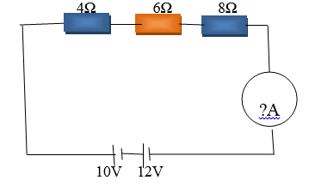 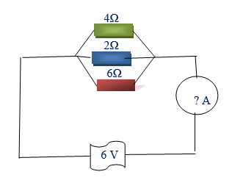 (4 marks) 4. . (A) Define the following i. cutting tools, ii. Electromotive force (emf), iii. Cell iv.current (2 marks)

(B) Calculate the voltage in circuits shown below (2 marks)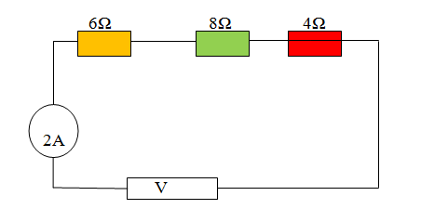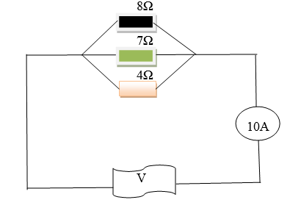

(C) Define the followingi. site preparation ii. Grubbing iii. Setting out iv. Dewatering (2 marks)

(D) Write names of electrical devices shown below in the box provided. (2 marks)

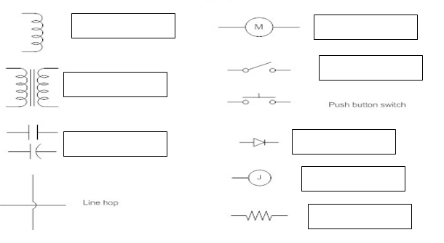

5. (A) List four safety precaution for handling woodwork hand tools. (2 marks)

(B) State four effect of electricity. (2 marks)

(C) List four safety precautions taken on metalwork handtools. (2 marks)

(D) List four types of magnets. (2 marks)